

FACULTY OF SCIENCE AND ENGINEERING

DEPARTMENT OF COMPUTER SCIENCE

______________________________________________________________________________

BACHELOR OF SCIENCE IN INFORMATION TECHNOLOGY
DEVELOPMENT OF A DIGITAL RDA SERVICE PORTAL FOR AGRICULTURAL INFORMATION ACCESS AND ONLINE TRACTOR BOOKING IN ESWATINI
Supervisor: Dr M Nxumalo
Coordinator: Mr. SM Sithole
Student: Mamba Thabani
ID: 202202427
Student: Ndzinisa Sakhile
ID:202202

____________________________________________________________________
ACADEMIC YEAR 2025-2026

Abstract
The RDA Agricultural Support Website is a web-based platform designed to improve access to agricultural services for farmers in Eswatini. The platform addresses longstanding challenges such as limited access to livestock and crop information, delayed climate and seasonal advice, and difficulties in obtaining training materials. It also solves the inefficiencies associated with the slow, manual process of booking subsidized tractor services offered by Rural Development Areas (RDAs).
The system centralizes agricultural information and digitizes tractor booking, allowing farmers to request services, specify their location, choose the number of hours needed, and make online payments through Mobile money means. The system will be developed using React.js, Tailwind CSS, JavaScript, Typescript, Node.js, Express.js, Pg4 admin and MySQL to ensure reliable data management and efficient service delivery. This solution enhances transparency, modernizes agricultural support systems, and improves farmers’ access to vital agricultural resources in Eswatini.

DECLARATION
We, Ndzinisa Sakhile and Mamba Thabani, hereby declare that this project documentation entitled "Development of a Digital RDA Service Portal for Agricultural Information Access and Online Tractor Booking in Eswatini" is our own original work and has not been submitted, either in whole or in part, for any other degree or examination at this or any other university.
All sources consulted and cited in this document have been duly acknowledged in the reference list.
Signature: _______________________________
Date: ____________________________________

Signature: _______________________________
Date: ____________________________________

Supervisor's Signature: _______________________________
Date: ____________________________________

ACKNOWLEDGEMENS
We would like to express our sincere gratitude to our project supervisor, Dr M Nxumalo, for his invaluable guidance, constructive feedback, and continuous support throughout the development of this project.
We are equally grateful to the staff of the Rural Development Areas (RDA) offices in Eswatini who participated in interviews and provided essential insights into the current agricultural service delivery processes.
We also wish to thank the smallholder farmers and few students who participated in the usability testing phase of this project. Their honest feedback greatly informed the final improvements made to the platform.
Finally, we would like extend heartfelt thanks to our families and friends for their unwavering encouragement and moral support throughout our academic journey.

TABLE OF CONTENTS
Abstract ii
Declaration……………………………………………………………………………………………………………………………………………. iii
Acknowledgements………………………………………………………………………………………………………………………………iv
CHAPTER 1: INTRODUCTION 1
1.1 Background of the Study 1
1.2 Problem Statement 1
1.3 Aim of the Project 2
1.4 Objectives 2
1.5 Project Questions 2
1.6 Scope of the Study 2
1.7 Significance of the Project 3
1.8 Definition of Key Terms 3
CHAPTER 2: LITERATURE REVIEW 5
2.1 Introduction 5
2.2 Theoretical Review 5
2.3 Empirical Review 6
2.3.1 Centralized Agricultural Advisory Information 6
2.3.2 Online Booking and Coordination of Mechanization Services 7
2.4 Related Existing Systems 7
Hello Tractor 7
e-Choupal 8
Digital Green 8
2.5 Summary 8
CHAPTER 3: METHODOLOGY 10
3.1 Introduction 10
3.2 Research Design 10
3.3 Data Collection Methods 11
3.3.1 Interviews 11
3.3.2 Observations 11
3.4 System Development Approach 12
3.4.1 Selected Model: Waterfall Methodology 12
3.4.1.1 Requirements Analysis 12
3.4.1.2 System Design 13
3.4.1.3 Implementation 14
3.4.1.4 Testing 14
3.5 Requirements Analysis 15
3.5.1 Functional Requirements 15
3.5.2 Non-Functional Requirements 15
Usability 16
Security 16
Reliability 16
Performance 16
Scalability 16
3.6 System Design 16
3.6.1 System Modelling Techniques 16
Use Case Diagrams 17
Data Flow Diagrams (DFDs) 17
Entity Relationship Diagrams (ERDs) 18
Wireframes 19
3.6.2 System Architecture 25
Presentation Layer 25
Application Layer 26
Data Layer 26
3.7 System Implementation 26
3.7.1 Advisory Module 26
3.7.2 Booking Module 26
3.7.3 Administrative Module 27
3.8 System Testing 27
3.8.1 Functional Testing 27
3.8.2 Usability Testing 27
3.8.3 Performance Testing 27
3.8.4 Security Testing 28
3.9 Ethical Considerations 28
3.10 Deployment 28
3.11 Summary 29
CHAPTER 4: SYSTEM IMPLEMENTATION AND RESULTS 30
4.1 Introduction 30
4.2 Development Environment 30
4.3 System Modules 30
Homepage 30
Account Creation 31
Login Page 32
Admin Page 33
4.4 Database Implementation 37
4.5 System Testing 38
4.5.1 Functional Testing 38
4.5.2 Usability Testing 39
4.5.3 Performance Testing 39
4.5.4 Security Testing 40
4.5.5 Testing Summary 40
4.6 Implementation Summary 40
CHAPTER 5: CONCLUSION AND RECOMMENDATIONS 42
5.1 Introduction 42
5.2 Conclusion 42
5.3 Achievements of the Project 43
5.4 Challenges Encountered 43
Difficulty Accessing APIs 43
Limited Technical Resources 44
Time Constraints 44
Understanding System Integration 44
User Requirement Interpretation 44
5.5 Limitations of the Study 44
5.6 Future Work and Recommendations 45
Mobile Application Development 45
Full Mobile Money API Integration 45
GPS and Tractor Tracking 45
Offline Functionality 45
Expansion of Agricultural Services 45
Deployment Across Multiple RDAs 46
5.7 Final Remarks 46

CHAPTER 1: INTRODUCTION

1.1 Background of the Study
Agriculture remains a key economic activity in Eswatini, with many smallholder farmers relying on government-supported services such as livestock advisory, crop extension support, mechanization, and climate information. However, the delivery of these services is often constrained by limited access to updated information and slow administrative processes at Rural Development Areas (RDAs).
Currently, many farmers must travel long distances to RDA centers to book tractor services or obtain advisory information, resulting in delays, additional costs, and reduced productivity. These inefficiencies contribute to low crop yields, poor planning, and missed agricultural seasons.
With increasing digital adoption across Africa, ICT tools such as mobile phones and web platforms offer new opportunities to improve agricultural service delivery. Digitizing the RDA support system will allow farmers to access critical information and services more conveniently, increasing productivity and supporting national agricultural development goals.
This project proposes the development of an RDA Agricultural Support Website that centralizes agricultural information and digitizes tractor booking and payments. The system will make agricultural services more efficient, accessible, and transparent for farmers in Eswatini.

1.2 Problem Statement
Accessing key agricultural services such as soil testing information, livestock information, climate updates, and mechanization remains difficult for many smallholder farmers in Eswatini. Manual processes for booking subsidized tractor services are slow and inefficient. Farmers must often travel long distances to RDA offices, causing delays and increased costs.
Additionally, information on livestock management, crop guidance, and seasonal advisories is not centralized, making it hard for farmers to make timely and informed decisions. These challenges contribute to lower productivity, inefficient resource use, and limited adoption of modern farming techniques.

1.3 Aim of the Project
The aim of this project is to develop a digital agricultural support platform that improves access to agricultural information and enables farmers in Eswatini to book subsidized tractor services online, thereby enhancing efficiency, transparency, and service delivery within Rural Development Areas (RDAs).

1.4 Objectives

- To investigate the existing RDA Tractor booking and agricultural information service delivery processes.
- To develop a web-based RDA platform for agricultural information access and online tractor service booking.
- To evaluate the usability and effectiveness of the developed RDA platform for farmers and RDA officers in Eswatini.

1.5 Project Questions
- How can digital platforms improve access to agricultural information for farmers in Eswatini?
- How can the booking of subsidized tractor services be digitized for efficiency and transparency?
- What features are essential for a web-based agricultural support system to meet the needs of smallholder farmers?
- How can mobile money integration improve convenience and security in online agricultural transactions?

1.6 Scope of the Study
The project focuses on smallholder farmers within the RDA jurisdiction in Eswatini. It covers:
- Online access to agricultural information, including crop guidance, livestock management, soil advice, and seasonal advisories.
- Online booking of subsidized tractor services.
- Mobile money integration for payments
- System development using React.js, Tailwind CSS, JavaScript, Typescript (front-end), Node.js, Express.js, Pg4 admin, MySQL (back-end) Mobile-Money (payment).
The project does not cover other agricultural services such as fertilizer distribution, market price negotiation, or large-scale industrial farm mechanization.

1.7 Significance of the Project
- Improves Access to Agricultural Information
The platform gives farmers quick and reliable access to agricultural advice, livestock information, seasonal guidance, and training materials helping them make better farming decisions.
- Enhances Service Efficiency for RDAs
By digitizing manual processes such as tractor service requests, the system reduces delays, limits paperwork, and helps RDAs manage farmer requests more efficiently.
- Strengthens Farmer–RDA Communication
The platform simplifies communication by providing accessible contact details, updated announcements, and centralized support, improving the relationship between farmers and extension officers.
- Supports Agricultural Productivity and Rural Development
Easier access to mechanization services and agricultural knowledge empowers farmers to improve yields, reduce production challenges, and contribute to food security and economic growth.

1.8 Definition of Key Terms
- ICT (Information and Communication Technology): This are tools and systems used to communicate, store, and process information digitally.
- RDA (Rural Development Area): Government-administered area providing agricultural support services.
- Mechanization: Use of machinery such as tractors to perform agricultural activities.
- Mobile Money: Electronic payment system using mobile phones (e.g., MoMo, eMali).
- Smallholder Farmer: Farmer operating a small-scale farm, often relying on subsistence and limited resources.

CHAPTER 2: LITERATURE REVIEW

2.1 Introduction
This chapter reviews existing literature relevant to digital agricultural information systems and online service-booking platforms. The review is structured according to the two main objectives of the project:
(1) the centralization and digital delivery of agricultural advisory information; and
(2) online booking and coordination systems for mechanization services.
The chapter also examines related systems implemented globally and regionally and highlights gaps that the proposed RDA system can address.

2.2 Theoretical Review
The design of ICT interventions for agriculture is often grounded in Diffusion of Innovations Theory, which explains how new technologies are adopted within a community. Rogers (2003) identifies factors such as relative advantage, compatibility, simplicity, and trialability as key determinants of adoption. These factors are especially relevant in rural agricultural contexts, where digital literacy and access to infrastructure can influence uptake.
Digital extension frameworks also form part of the theoretical foundation for this study. According to FAO (2022), effective digital agricultural systems require user-centered design, multimodal communication channels, and institutional integration with government or extension structures. These theoretical perspectives guide the development of a digital agricultural service portal that is simple, beneficial, and compatible with farmer needs.

2.3 Empirical Review

2.3.1 Centralized Agricultural Advisory Information
Access to timely, relevant, and credible agricultural information is widely recognized as a major contributor to improved productivity among smallholder farmers. FAO (2022) emphasizes that digital platforms significantly enhance the reach of extension services by providing centralized access to agronomic advice, livestock information, and climate-smart agriculture guidance. A systematic review by Ayim et al. (2022) found that ICT-enabled advisory systems such as mobile apps, web portals, and SMS-based services have improved farmers’ knowledge and decision-making across several African countries.
One of the best-documented digital advisory systems is e-Choupal in India. The platform centralizes information on crop management, market prices, and weather updates, enabling farmers to make better-informed production and marketing decisions. Evaluations of e-Choupal (ITC case studies; see APAARI 2015) demonstrate improvements in transparency and access to extension services but also reveal limitations such as dependence on local agents and uneven digital access in remote regions.
Recent analyses further highlight challenges in existing digital extension initiatives. Choruma (2024), in a scoping review of digital agricultural extension in Africa, notes that many systems lack localized content, provide limited two-way communication, or fail to integrate fully with national extension services. Furthermore, many platforms operate in pilot mode and are not institutionalized, leading to sustainability issues once donor funding ends (FAO, 2022).
Existing literature clearly shows that centralizing advisory information is beneficial, but current systems often suffer from limited accessibility, weak institutional integration, and insufficient localization. Our project aim address these gaps by providing locally verified information, integrating the system directly within RDA operations, and ensuring a unified access point for agricultural resources in Eswatini.

2.3.2 Online Booking and Coordination of Mechanization Services
Digital booking systems for farm mechanization have gained global attention as a solution to low tractor utilization and limited access to mechanization for smallholder farmers. The most studied initiative is Hello Tractor, which uses a digital platform to connect tractor owners with farmers needing services. Case studies show that the platform enhances scheduling efficiency, reduces transaction costs, and increases tractor utilization (Daum, 2021). It also demonstrates the value of digital tracking, agent-assisted booking, and real-time visibility of service availability.
FAO (2020) similarly notes that digital coordination platforms can strengthen the management of subsidized mechanization programs by improving transparency and record-keeping. However, studies indicate that many mechanization platforms rely heavily on smartphone use and stable internet access factors that remain limited in rural Africa. Daum (2021) further points out that successful mechanization platforms must consider operational realities such as fuel availability, operator shortages, and last-mile logistics.
Other booking systems outside the agricultural sector, such as health appointment portals and transportation scheduling systems, offer insights into efficient digital scheduling models. These systems commonly feature automated confirmations, service logs, user accounts, and clear service descriptions all of which enhance transparency and user experience.
Although existing digital mechanization systems have shown promise, gaps remain in government integration, inclusion of low digitally skilled farmers, and transparency in subsidized service allocation. Our system aims to bridge these gaps by offering a simplified booking interface, supporting manual fallback assistance (e.g., through RDA officers), and embedding administrative oversight into the booking workflow.

2.4 Related Existing Systems

Hello Tractor
Hello Tractor is a leading digital mechanization platform operating in parts of Africa and Asia. It enables farmers to request tractor services through mobile technology while offering fleet management features such as GPS tracking, service logging, and operator management. Its success demonstrates that digital booking can reduce inefficiencies, but its reliance on agents and digital accessibility highlights a need for more inclusive, government supported systems (Daum, 2021).

e-Choupal
e-Choupal represents one of the earliest and most influential digital agricultural information platforms. The system provides farmers with localized advisory information, market data, and training resources. Evaluations indicate improved access to information and reduced market inefficiencies, yet challenges related to infrastructure and sustainability persist (APAARI, 2015).

Digital Green
Digital Green extends advisory content through community video based learning supported by digital tools. It has proven effective in improving awareness and adoption of recommended practices, but relies heavily on community facilitators and is less focused on mechanization or service scheduling.
Together, these systems show that digital platforms can transform agricultural service delivery but must address accessibility, sustainability, and integration challenges to remain impactful.

2.5 Summary
The literature demonstrates strong global evidence supporting digital agricultural information systems and mechanization booking platforms. Existing systems like e-Choupal, Digital Green, and Hello Tractor show that centralized information delivery and digital coordination can improve productivity and service efficiency. However, limitations such as constrained digital access, weak institutional integration, and poor sustainability remain common.
The Development of a digital RDA service portal for agricultural information access and online tractor booking in Eswatini seeks to address these limitations by creating a unified, locally relevant, and government integrated system that centralizes advisory information and enables transparent booking of mechanization services for farmers in Eswatini.

CHAPTER 3: METHODOLOGY

3.1 Introduction
This chapter presents the methodology that guided the development of the RDA Agricultural Advisory and Online Booking System. It explains the research design, data collection methods, system development approach, system requirements, design techniques, implementation procedures, testing methods, and ethical considerations were followed during the study. The methodology was selected to ensure that the system is developed in a structured, systematic, and user-centered manner.
The chapter also explains the rationale behind the selection of each method and technology to ensure that the proposed system effectively addresses the challenges faced by farmers and RDA officers in accessing agricultural advisory information and mechanization booking services.

3.2 Research Design
The study adopted a Design and Development Research (DDR) approach. This research design is suitable because it supports both the investigation of real-world problems and the development of a practical technological solution.
The DDR approach was selected because the project aims not only to understand the challenges experienced within the agricultural advisory and tractor-booking processes, but also to design and develop a system capable of addressing those challenges. The approach therefore combines problem analysis with system development.
The research design will focus on two main areas:
- Investigating the challenges associated with accessing agricultural advisory information and mechanization services.
- Designing and developing a digital platform that improves communication, information access, and booking efficiency.
This design ensured that the proposed system is based on actual user needs and operational requirements identified during data collection.

3.3 Data Collection Methods
Data collection methods were selected to gather reliable and relevant information regarding the existing agricultural advisory and tractor-booking processes. The collected data was to assist in identifying system requirements and understanding operational challenges faced by both farmers and RDA staff.

3.3.1 Interviews
Semi-structured interviews were conducted with RDA officers and extension staff. This method was chosen because it allows direct interaction with participants while providing flexibility for follow-up questions and detailed explanations.
The interviews were conducted to gather information regarding:
- Existing methods of disseminating agricultural advisory information
- Challenges faced by farmers when seeking agricultural guidance
- Problems associated with the current manual tractor-booking process
- Limitations in communication and record management
The interview method was considered appropriate because it provided detailed qualitative information that could not easily be obtained through observation alone. The information collected assisted in defining the functional and non-functional requirements of the proposed system.

3.3.2 Observations
Direct observations were conducted at RDA offices to understand how daily agricultural advisory and tractor-booking operations are currently performed. Observation was selected because it allows the researcher to witness actual processes and workflows within their natural environment.
During the observation process, attention was given to:
- How farmers request tractor services
- How advisory information is distributed to farmers
- Administrative procedures involved in booking services
- Current methods of recording and storing booking information
The observation method was important because it provided practical insight into inefficiencies, delays, and communication gaps that may not have been fully explained during interviews. It also helped validate information obtained from participants.

3.4 System Development Approach

3.4.1 Selected Model: Waterfall Methodology
The project used the Waterfall software development methodology. The Waterfall model was selected because it provides a clear and structured sequence of development activities. It also emphasizes proper documentation and planning at each stage of development, making it suitable for academic and information management systems.
The methodology was appropriate for this project because the major system requirements were already identified through interviews and observations, reducing the likelihood of frequent requirement changes during development.
The Waterfall methodology consist of the following phases:

3.4.1.1 Requirements Analysis
This phase involved analyzing information gathered through interviews, observations, and document review in order to identify the requirements of the system.
Functional and non-functional requirements were identified to ensure that the proposed system addresses the needs of farmers, RDA officers, and administrators. This phase was important because it established the foundation upon which the entire system was designed and developed.
Activities carried out during this phase include:
- Identifying user requirements
- Defining system functions
- Identifying system constraints
- Documenting system specifications

3.4.1.2 System Design
During this phase, the structure and layout of the system was planned and designed. The system architecture, database structure, interfaces, and workflows were designed according to the identified requirements.
System modelling techniques such as use case diagrams, data flow diagrams, entity relationship diagrams, and wireframes were used to provide a clear representation of system operations and data movement.
This phase was important because it provided the blueprint that guided the implementation process and reduced development errors.
Activities during this phase included:
- Designing user interfaces
- Designing the database structure
- Designing system workflows
- Preparing system models and diagrams

3.4.1.3 Implementation
The implementation phase involved developing the actual system according to the approved design specifications.
The project focused on developing:
- The agricultural advisory module
- The tractor booking module
- The administrative management module
The implementation process involved coding, database configuration, and integration of system components.
The following technologies were used during development:
React.js, Tailwind CSS, JavaScript, Typescript (front-end), Node.js, Express.js, Pg4 admin, MySQL (back-end) Mobile-Money (payment).
These technologies were selected because they are suitable for developing web-based information systems and support efficient data management, user interaction, and system scalability.

3.4.1.4 Testing
Testing was conducted to ensure that the proposed system functions correctly and satisfied user requirements. The testing phase is important because it helps identify system errors, usability issues, and security weaknesses before deployment.
The following testing activities were carried out:
- Functional testing
- Usability testing
- Performance testing
- Security testing
The testing process improve system reliability, efficiency, and user satisfaction.

3.5 Requirements Analysis

3.5.1 Functional Requirements
Functional requirements describe the services and operations that the system must perform. These requirements were identified from information gathered during interviews and observations.
The system:
- Display agricultural advisory information related to crops, livestock, soil management, and climate conditions
- Allow RDA officers to upload training materials and seasonal updates
- Provide a digital platform for farmers to request tractor and mechanization services
- Allow farmers to specify service type, location, and duration
- Generate booking confirmations
- Enable administrators to manage users, bookings, and advisory content

3.5.2 Non-Functional Requirements
Non-functional requirements describe the quality attributes and operational standards that the system should satisfy.
The proposed system was designed to meet the following non-functional requirements:

Usability
The system interface was designed to be simple and easy to navigate for users with different levels of digital literacy.

Security
Security measures were implemented to protect user credentials and booking information from unauthorized access.

Reliability
The system was designed to provide consistent access to advisory information and booking services with minimal downtime.

Performance
The system was optimized to ensure fast loading speeds and efficient processing of user requests.

Scalability
The system architecture supports future expansion to accommodate more users and additional RDAs.

3.6 System Design

3.6.1 System Modelling Techniques
The system was modelled using various modelling techniques to provide a clear understanding of system functionality and data flow.
The following techniques were used:

Use Case Diagrams
Use case diagrams were used to illustrate interactions between users and the system.
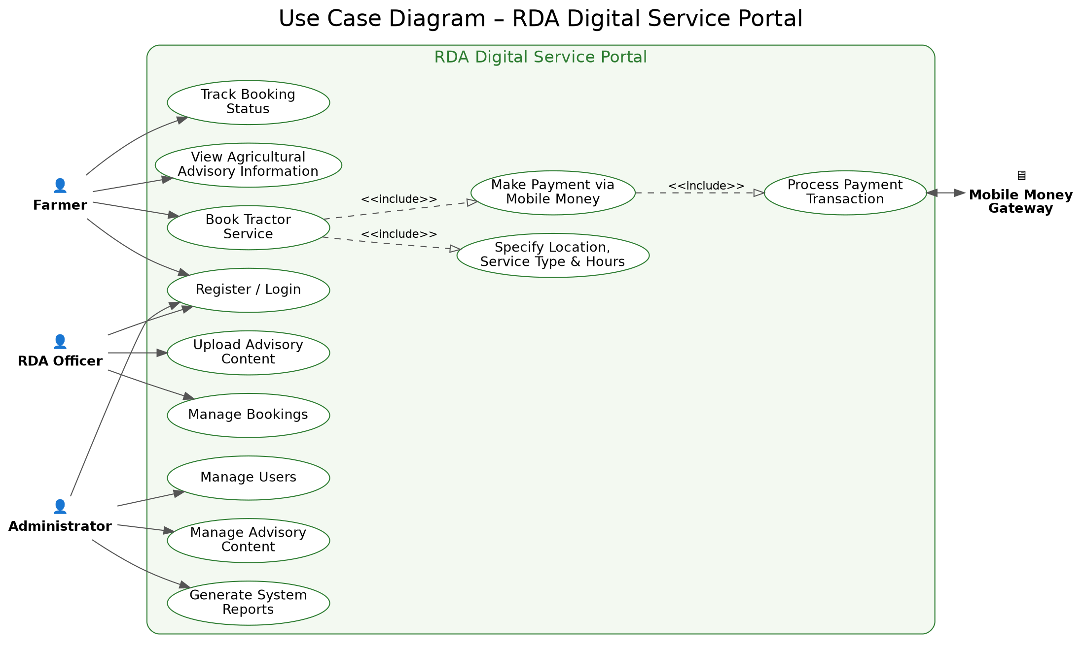
Figure 3.6.1: Use Case Diagram of the RDA Digital Service Portal

Data Flow Diagrams (DFDs)
DFDs were used to illustrate how information moves within the system.
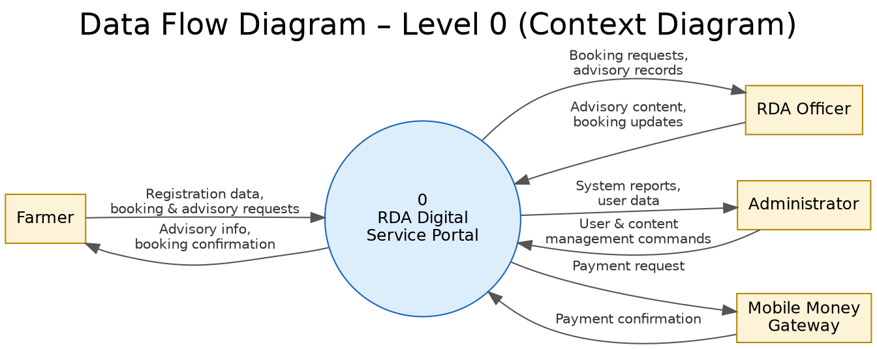
Figure 3.6.2: Data Flow Diagram - Level 0 (Context Diagram)
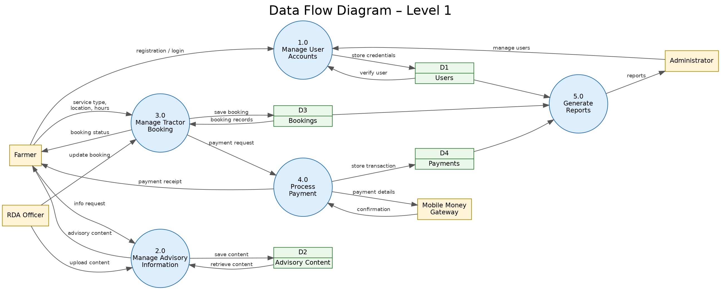
Figure 3.6.3: Data Flow Diagram - Level 1

Entity Relationship Diagrams (ERDs)
ERDs were used to model the database structure and relationships between entities.
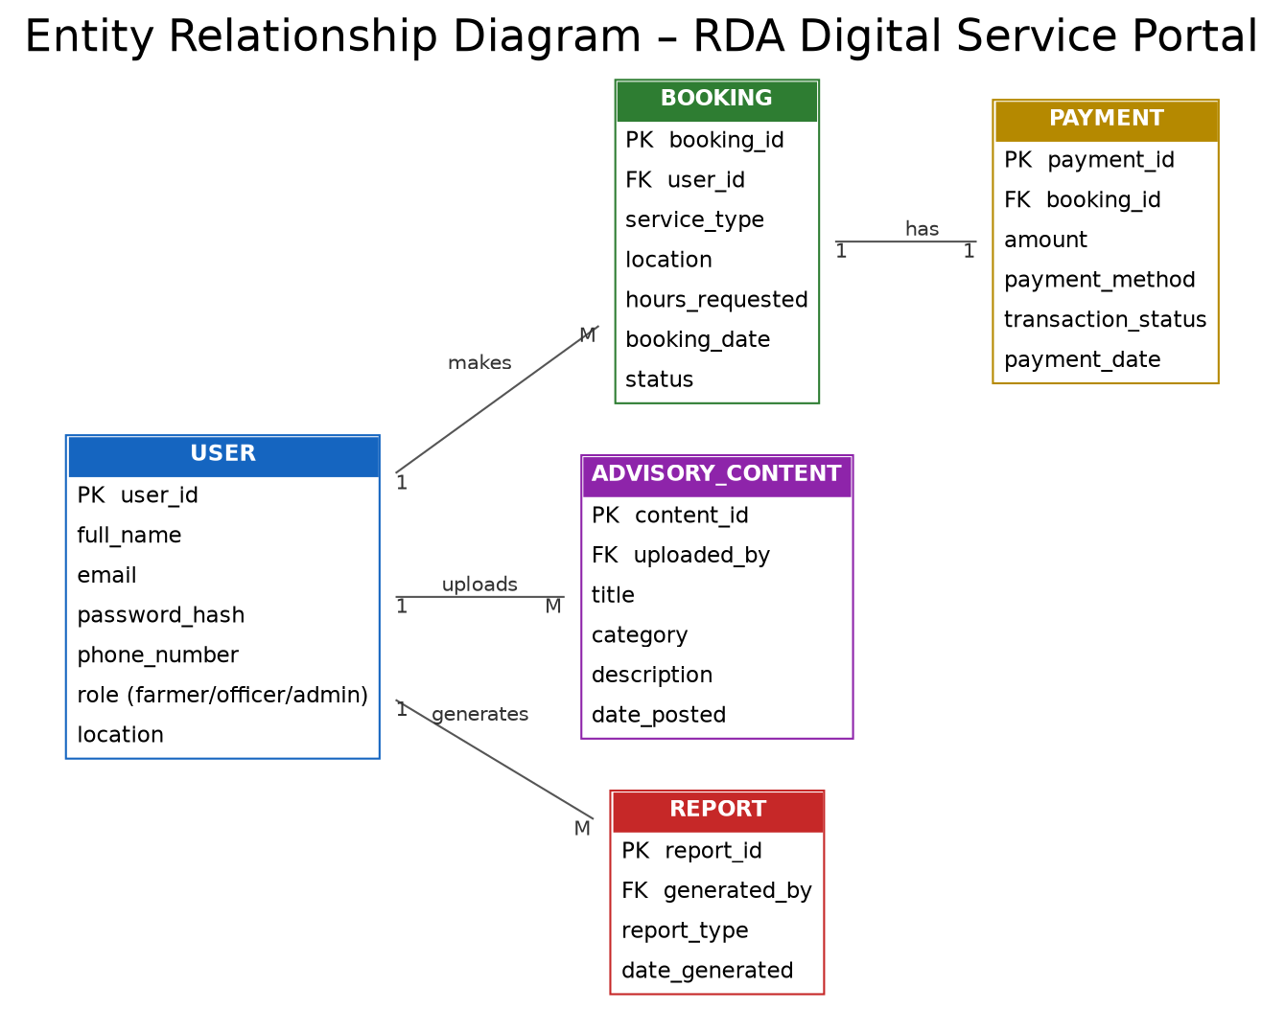
Figure 3.6.4: Entity Relationship Diagram (ERD) of the RDA Digital Service Portal

Wireframes
Wireframes were used to design and visualize the layout of user interfaces before implementation.
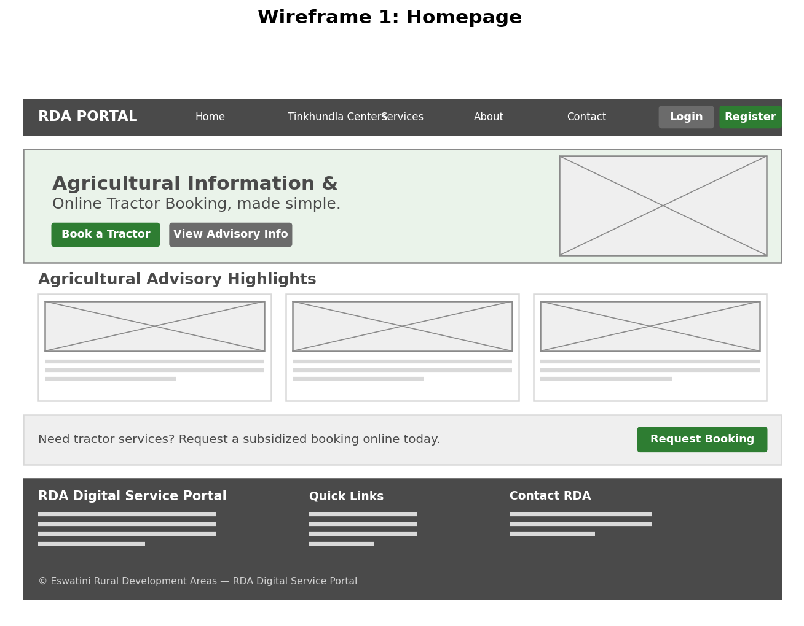
Figure 3.6.5: Wireframe - Homepage
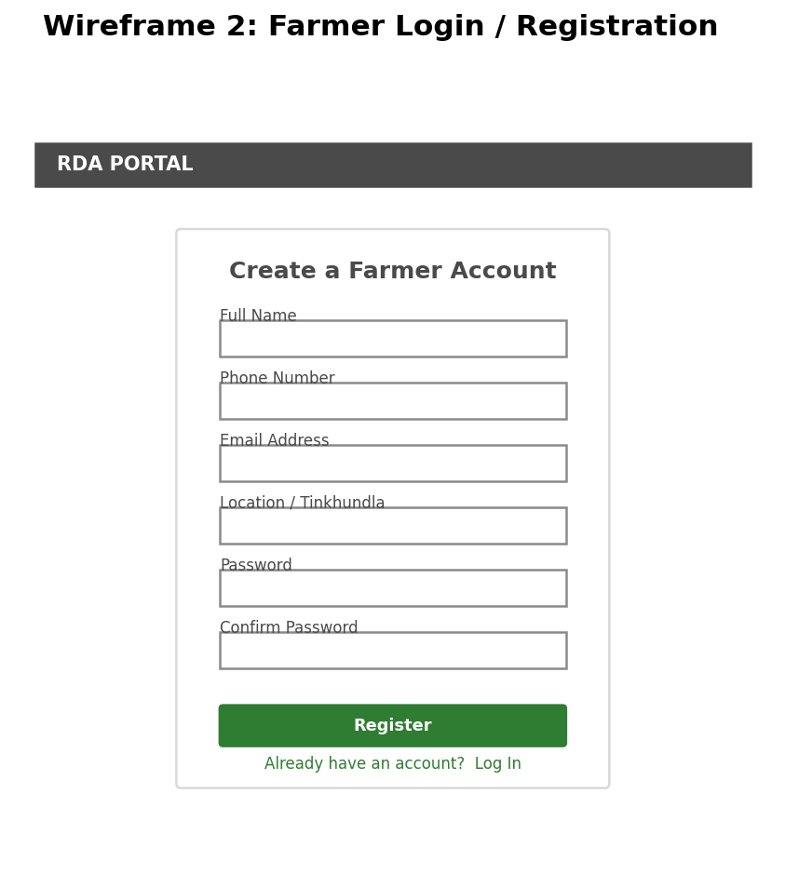
Figure 3.6.6: Wireframe - Farmer Login / Registration
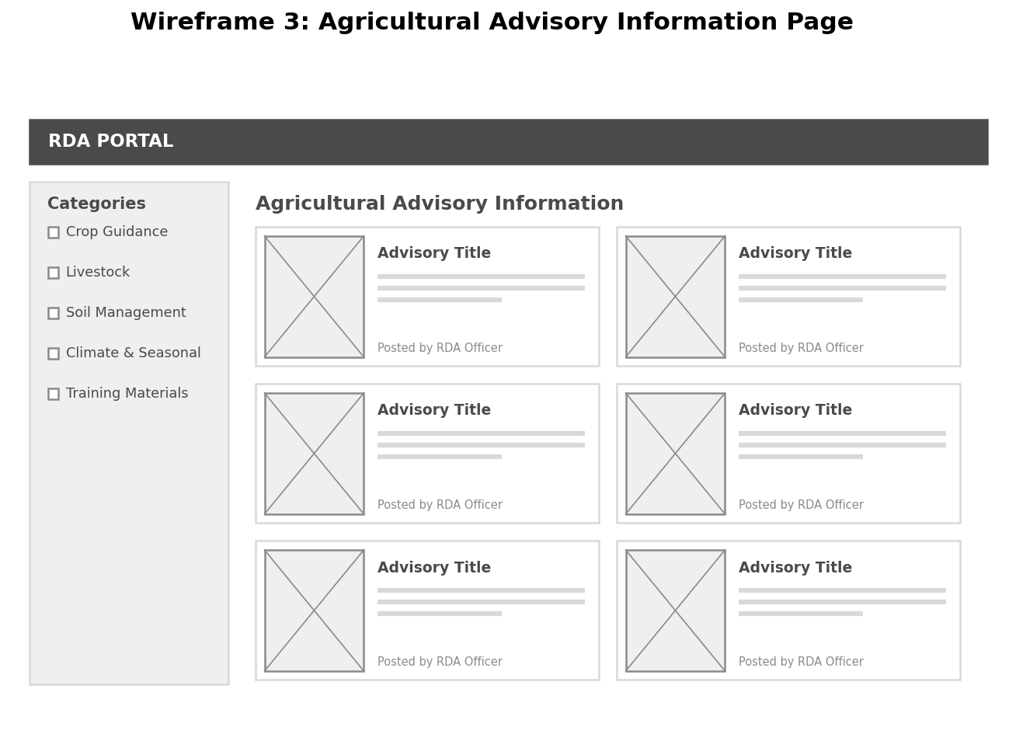
Figure 3.6.7: Wireframe - Agricultural Advisory Information Page
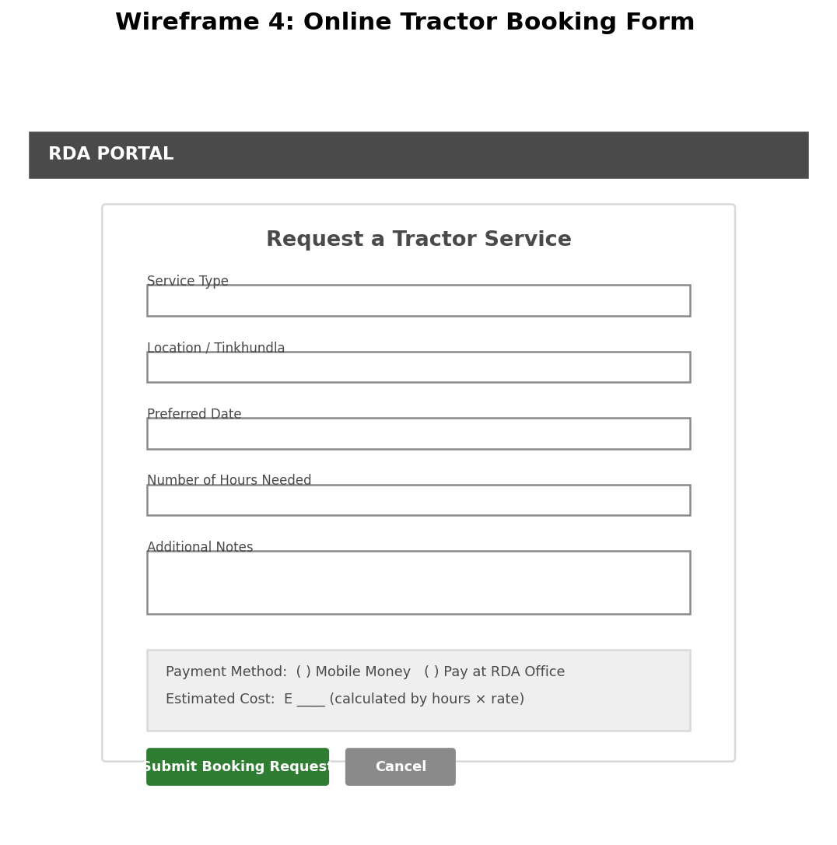
Figure 3.6.8: Wireframe - Online Tractor Booking Form
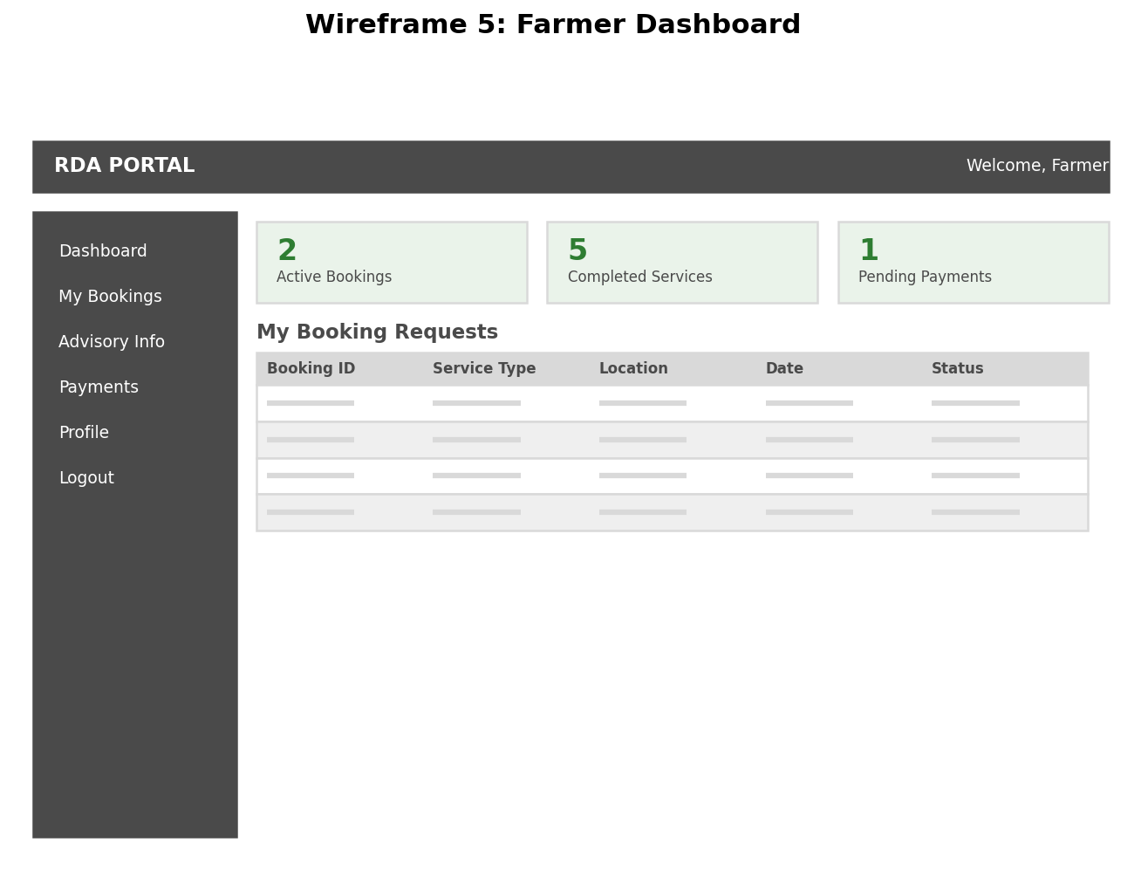
Figure 3.6.9: Wireframe - Farmer Dashboard
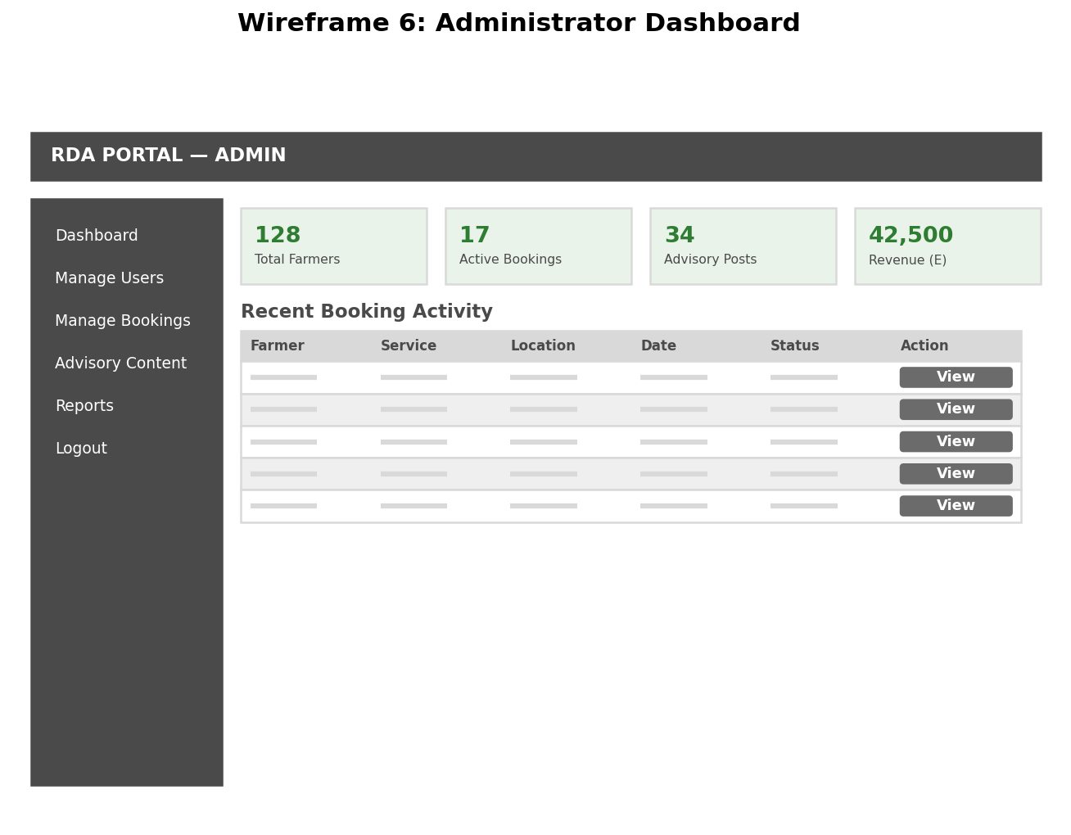
Figure 3.6.10: Wireframe - Administrator Dashboard
These modelling tools will assist in improving system planning, communication, and development accuracy.

3.6.2 System Architecture
The proposed system adopted a three-tier architecture consisting of:

Presentation Layer
This layer contains interfaces for farmers, RDA officers, and administrators.

Application Layer
This layer contains the business logic responsible for processing bookings, managing advisory content, and handling user requests.

Data Layer
This layer manages the storage of user information, booking records, and advisory content within the database.
The three-tier architecture was selected because it improves system organization, maintenance, scalability, and security.

3.7 System Implementation

3.7.1 Advisory Module
This module:
- Provide agricultural information on crops, livestock, soil management, and climate conditions
- Allow RDA officers to upload and manage advisory content
- Display training manuals and seasonal farming guidance

3.7.2 Booking Module
This module:
- Allow farmers to request mechanization services
- Capture booking details such as location, service type, and duration
- Generate booking confirmations
- Provide RDA officers with booking management functions

3.7.3 Administrative Module
This module:
- Manage users and system content
- Monitor booking activities
- Generate reports and administrative records

3.8 System Testing

3.8.1 Functional Testing
Functional testing was conducted to ensure that each feature performs according to the specified requirements.

3.8.2 Usability Testing
Usability testing sessions were conducted with selected users to evaluate:
- Ease of navigation
- Readability of information
- Efficiency of the booking process
- Overall user experience

3.8.3 Performance Testing
Performance testing was carried out to evaluate system responsiveness, loading speed, and the ability to handle multiple user requests.

3.8.4 Security Testing
Security testing was conducted to ensure that user data, login credentials, and booking information are protected from unauthorized access.

3.9 Ethical Considerations
Ethical principles were observed throughout the study and system development process.
The study ensured:
- Voluntary participation during interviews
- Confidentiality of collected information
- Responsible handling of user data
- Avoidance of unnecessary collection of personal information
- Accuracy and reliability of agricultural advisory content
These ethical considerations are important in maintaining trust, protecting participants, and ensuring responsible system development.

3.10 Deployment
Deployment refers to the process of making a developed system available for use in its intended operational environment. In this project the system was developed, tested, and validated within a controlled environment. However, the system was not deployed for actual use because deployment requires prior review, approval and acceptance by relevant authorities and stakeholders.
The decision not to deploy the system at this stage was made to ensure compliance with organizational policies, regulatory requirements, and operational standards.

3.11 Summary
This chapter presented the methodology that will guide the development of the RDA Agricultural Advisory and Online Booking System. The chapter discussed the research design, data collection methods, Waterfall development methodology, requirements analysis, system design techniques, implementation procedures, testing methods, and ethical considerations.
The selected methodology will support the structured development of a reliable, secure, and user-friendly system capable of improving access to agricultural advisory information and mechanization booking services within the RDA environment.

Top of Form

CHAPTER 4: SYSTEM IMPLEMENTATION AND RESULTS

4.1 Introduction
This chapter presents the implementation and operational results of the developed Digital RDA Service Portal. The developed system transformed manual agricultural information access and tractor booking procedures into a centralized digital platform. The implementation process involved integrating user interfaces, databases, booking processes, payment services, and administrative functionality.

4.2 Development Environment
The system was developed using Visual Studio Code. React.js and Tailwind CSS were used for front-end development while Node.js and Express.js were used for backend processing. MySQL was used as the database management system.

4.3 System Modules
The system consisted of an Agricultural Advisory Module, Tractor Booking Module and Administrative Module. The Agricultural Advisory Module provided crop and livestock information. The Tractor Booking Module allowed farmers to request services and make payments. The Administrative Module allowed management of users and content.

Homepage
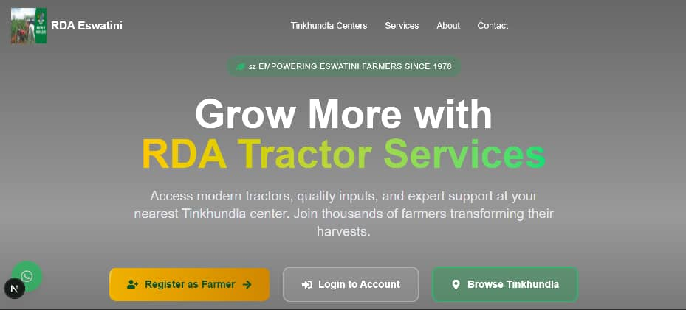
Figure4.3.1: Homepage.
The home page serves as the main entry point of the RDA Digital Service Portal. It provides users with access to important agricultural services and information. The page contains a navigation menu linking users to sections such as Tinkhundla Centers, Services, About, and Contact pages.
The interface also includes action buttons for farmer registration, user login, and browsing available Tinkhundla centers. The main section introduces users to RDA tractor services and agricultural support provided through the platform.
- Register as Farmer – Allow new users to create farmer accounts within the system.
- Login to account – Enable registered users and administrators to securely access their accounts.
- Browse Tinkhundla – Allow users to view available service centers and agricultural support locations.
The page was developed using React.js and Tailwind CSS to provide a responsive and user-friendly interface accessible on both desktop and mobile devices.

Account Creation
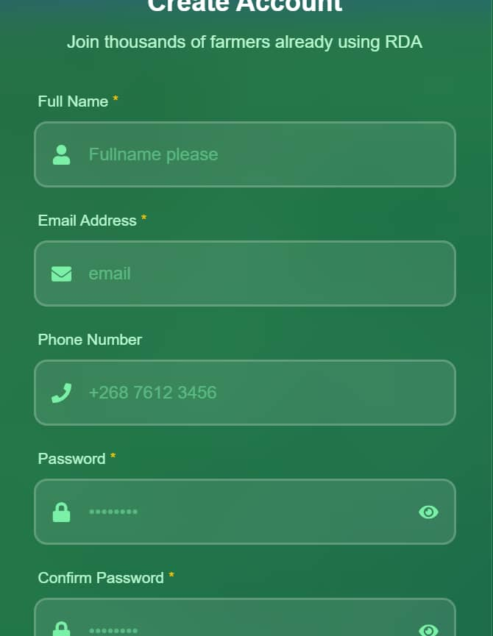
Figure 4.3.2: Account creation.
The account creation page allows farmers to register and create accounts within the RDA Digital Service Portal. The interface contains input fields for full name, email address, phone number, password, and password confirmation.
This functionality enables users to securely access system services such as tractor booking, agricultural information, and payment processing. The page also includes password visibility controls to improve usability during account creation.
The interface was designed to be simple and user-friendly in order to accommodate users with different levels of digital literacy. The interface was developed using React.js, Tailwind CSS, JavaScript, and Typescript to provide a responsive, secure, and user-friendly registration experience.

Login Page
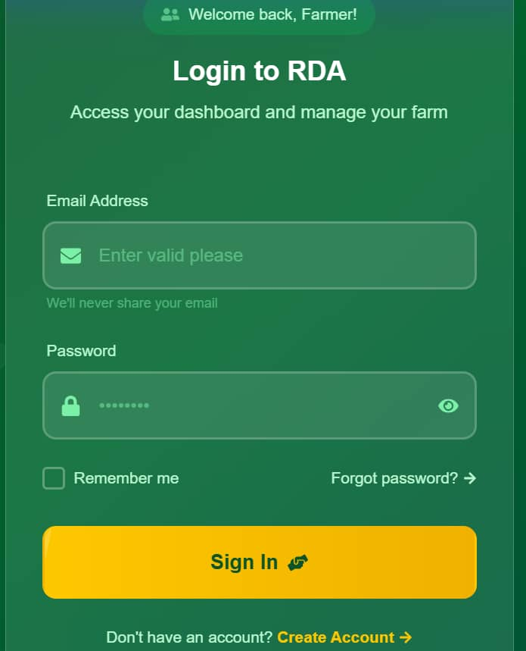
Figure4.3.3: Login page.
The login page allows registered farmers and administrators to securely access the RDA Digital Service Portal using their email address and password. The interface contains input fields for email and password together with a “Remember Me” option and password recovery feature.
The page was designed to improve system security by ensuring that only authorized users can access protected services such as tractor booking, payment processing, and account management. The “Create Account” link also allows new users to register within the system.
The interface was developed using React.js, Tailwind CSS, JavaScript, and Typescript to provide a responsive, secure, and user-friendly login experience.

Admin Page
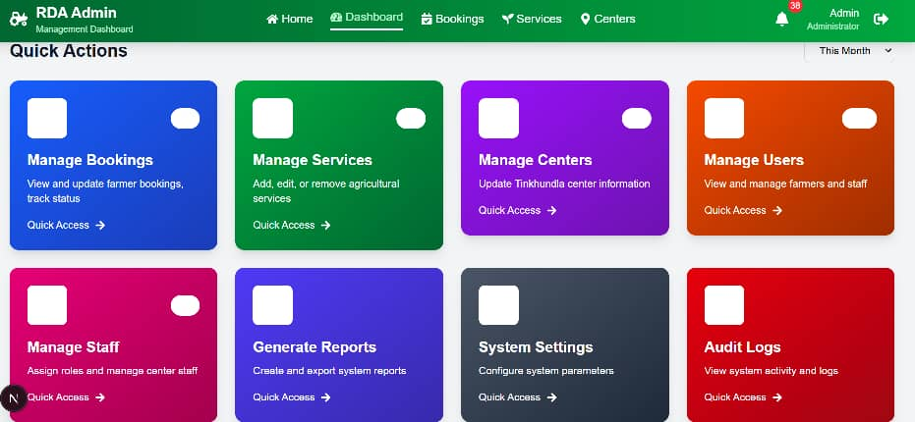
Figure4.3.4: Administration interface.
The administrative dashboard provides administrators with centralized management and monitoring functions within the RDA Digital Service Portal. The interface contains quick access panels for managing bookings, services, Tinkhundla centers, users, staff, reports, system settings, and audit logs.
The dashboard enables administrators to monitor farmer activities, update agricultural services, manage system users, and generate reports related to tractor bookings and system usage. The interface improves efficiency by centralizing all administrative operations within a single platform.
The administrative dashboard was developed using React.js, Tailwind CSS, JavaScript, and Typescript to provide a responsive, organized, and user-friendly management interface.
Tractor Booking Page

Figure4.3.5: Tractor booking.

The tractor booking page allows farmers to request tractor services online through the RDA Digital Service Portal. The interface captures personal details such as full name, contact number, and email address together with service details including location description, required hours, and preferred booking date.
The page also includes mobile money payment functionality, allowing farmers to make payments directly through mobile money services. After submitting the booking request, the farmer enters the mobile number used for payment. A payment approval notification is then sent to the farmer’s mobile phone where the user confirms the transaction by entering their mobile money PIN. Once payment is successfully completed, the booking information is stored in the system database and confirmation is generated.
The booking summary section displays the total amount to be paid based on the number of hours selected for tractor services. This functionality improves transparency and simplifies the booking process for farmers.
The interface was developed using React.js, Tailwind CSS, JavaScript, Typescript, Node.js, and Express.js to provide a responsive, secure, and efficient online booking experience.

Farmer Dashboard

Figure4.3.6: Farmer dashboard
The farmer dashboard provides registered farmers with access to their tractor booking activities and agricultural services within the RDA Digital Service Portal. The interface displays booking statistics including total bookings, pending requests, confirmed bookings, and completed services.
The dashboard also provides a recent bookings section where farmers can view booking IDs, booking dates, payment amounts, and current booking status. The “View Details” option allows users to access additional booking information.
Quick action buttons such as “Book New Tractor,” “View Advisory Information,” and “Refresh Bookings” enable farmers to easily navigate system services. The dashboard also includes a tractor tracking feature that allows users to monitor booking progress and tractor status.
The interface was developed using React.js, Tailwind CSS, JavaScript, Typescript, Node.js, and Express.js to provide a responsive and user-friendly experience for farmers.
Advisory information page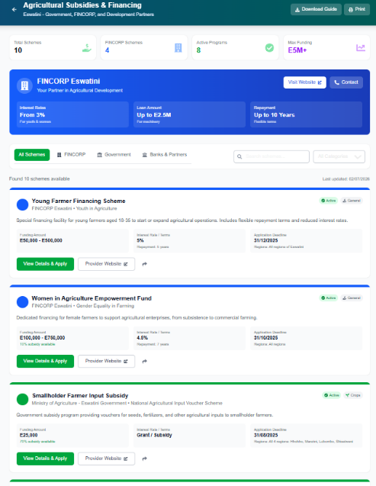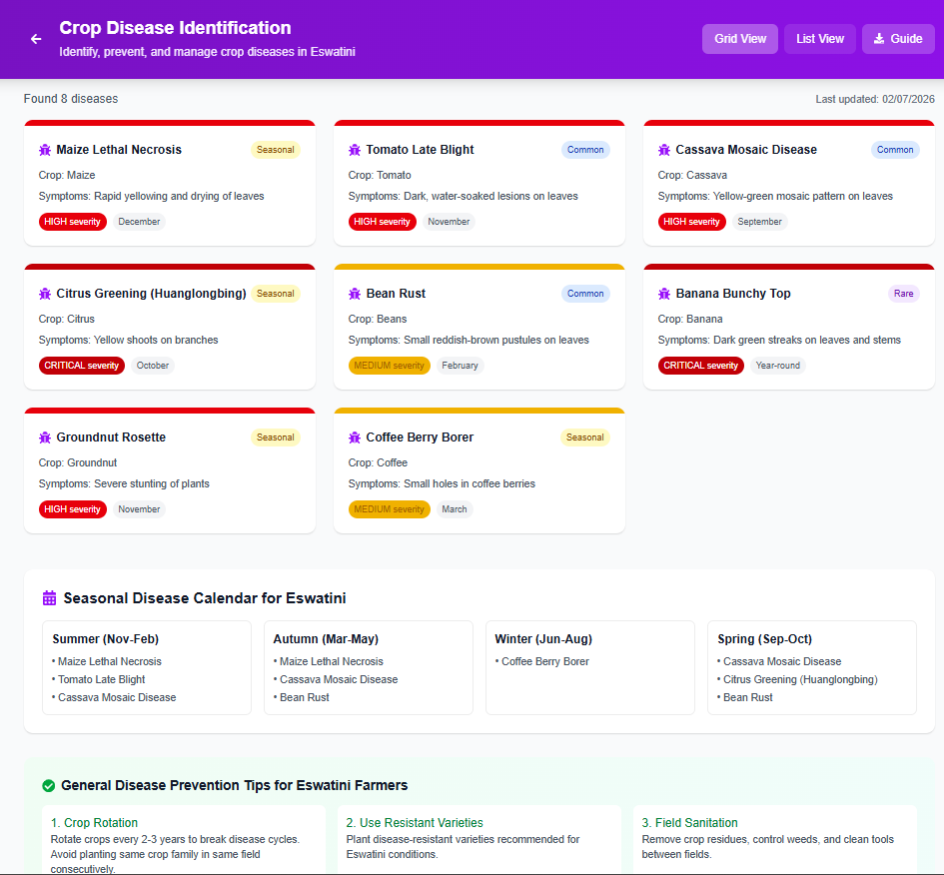

Figure4.3.7: advisory information page

The agricultural advisory information page allows farmers to access important farming information and guidance provided through the RDA Digital Service Portal. The interface displays advisory content related to crop production, livestock management, soil preparation, seasonal farming practices, and other agricultural updates uploaded by RDA officers.
This functionality enables farmers to access reliable and up-to-date agricultural information without visiting RDA offices physically. The system improves communication between farmers and agricultural extension officers by centralizing advisory services within a single digital platform.
The interface was developed using React.js, Tailwind CSS, JavaScript, Typescript, Node.js, and Express.js to provide an accessible, responsive and user-friendly information management system.

4.4 Database Implementation
The database contains Users, Bookings, Tinkhundla Centers, services, refunds, advisory resources, Payments and Advisory Content tables which maintained data integrity through relationships and keys.

4.5 System Testing
System testing was conducted to evaluate whether the developed Digital RDA Service Portal performs according to the specified system requirements. The testing process focused on identifying functional errors, usability problems, performance limitations, and security weaknesses before final deployment of the system.
Different testing techniques were applied to ensure that the system modules operated correctly and provided a reliable user experience for farmers, RDA officers, and administrators.

4.5.1 Functional Testing
Functional testing was performed to verify that all system features operated according to the defined functional requirements. Each module of the system was tested independently to ensure correct processing of user requests and system responses.
The following functionalities were tested:
- User registration and login
- Farmer dashboard access
- Tractor booking submission
- Mobile money payment processing
- Booking confirmation generation
- Advisory information access
- Administrative management functions
- Report generation and booking management
The testing confirmed that users were able to create accounts successfully, log into the system securely, submit tractor booking requests, and access advisory information without errors. Administrative functions such as managing users, bookings, and advisory content also operated successfully.

4.5.2 Usability Testing
Usability testing was conducted to evaluate the ease of use and overall user experience of the system. Selected users interacted with the platform and provided feedback regarding navigation, interface design, readability, and accessibility of information.
The following aspects were evaluated:
- Simplicity of the registration and login process
- Ease of navigating between pages
- Clarity of booking forms and instructions
- Accessibility of advisory information
- Overall user satisfaction
The results indicated that the system interface was simple, user-friendly, and easy to navigate for users with different levels of digital literacy. The responsive design also allowed users to access the system effectively on both desktop and mobile devices.

4.5.3 Performance Testing
Performance testing was conducted to evaluate the responsiveness and efficiency of the system during operation. The testing focused on page loading speed, booking processing time, and handling of multiple user requests.
The following areas were tested:
- System response time during login
- Speed of loading advisory content
- Booking request processing speed
- Database response efficiency
The results showed that the system responded efficiently under normal operating conditions. Pages loaded within acceptable time limits and booking requests were processed successfully without noticeable delays.

4.5.4 Security Testing
Security testing was carried out to ensure that user data and booking information were protected from unauthorized access. Security measures were evaluated to determine the effectiveness of authentication and data protection mechanisms implemented within the system.
The following security features were tested:
- User authentication and login validation
- Password protection mechanisms
- Access control for administrators and farmers
- Protection of booking and payment information
The testing confirmed that unauthorized users could not access restricted pages without valid login credentials. The system also protected sensitive information such as user details and booking records from unauthorized access.

4.5.5 Testing Summary
The testing process demonstrated that the Digital RDA Service Portal successfully met the functional and non-functional requirements identified during system analysis. The system operated reliably, provided a user-friendly interface, maintained acceptable performance levels, and ensured basic security for user information and booking data.
The successful completion of system testing confirmed that the developed platform is capable of improving agricultural information access and online tractor booking services for farmers and RDA officers in Eswatini.

4.6 Implementation Summary
This chapter presented the implementation and operational results of the developed Digital RDA Service Portal for Agricultural Information Access and Online Tractor Booking in Eswatini. The chapter discussed the development environment, system modules, database implementation, and system testing processes carried out during development.
The implementation process successfully transformed manual agricultural advisory and tractor booking procedures into a centralized digital platform. The developed system provided farmers with access to agricultural advisory information, online tractor booking services, mobile money payment functionality, and booking management features. Administrative functions for managing users, bookings, reports, and advisory content were also successfully implemented.
The chapter further demonstrated how technologies such as React.js, Tailwind CSS, JavaScript, Typescript, Node.js, Express.js, and MySQL were integrated to develop a responsive, secure, and user-friendly web application.
System testing was conducted through functional testing, usability testing, performance testing, and security testing. The testing results confirmed that the system performed according to the specified requirements, provided acceptable performance, maintained basic security, and offered a simple and accessible user experience for farmers and administrators.
Overall, the implementation and testing results showed that the developed Digital RDA Service Portal is capable of improving access to agricultural information, enhancing efficiency in tractor booking processes, and supporting better service delivery within Rural Development Areas in Eswatini.

CHAPTER 5: CONCLUSION AND RECOMMENDATIONS

5.1 Introduction
This chapter presents the conclusion of the study on the Development of a Digital RDA Service Portal for Agricultural Information Access and Online Tractor Booking in Eswatini. The chapter summarizes the achievements of the project, discusses challenges and limitations encountered during development, and presents recommendations and future improvements for the system.

5.2 Conclusion
The aim of this project was to develop a digital platform capable of improving access to agricultural advisory information and simplifying the process of booking subsidized tractor services within Rural Development Areas (RDAs) in Eswatini.
The study successfully investigated the challenges associated with traditional agricultural advisory and tractor-booking processes. Findings from interviews and observations revealed that farmers experienced difficulties accessing agricultural information, booking tractor services, and communicating efficiently with RDA offices due to manual processes and centralized service points.
To address these challenges, a web-based Digital RDA Service Portal was designed and developed. The developed system successfully centralized agricultural advisory information and introduced an online tractor booking platform integrated with mobile money payment functionality. The system also included administrative features for managing users, bookings, reports, and advisory content.
The implementation process demonstrated the practical application of web technologies such as React.js, Tailwind CSS, JavaScript, Typescript, Node.js, Express.js, and MySQL in developing a responsive and user-friendly agricultural support platform.
System testing was conducted through functional testing, usability testing, performance testing, and security testing. The testing results confirmed that the developed system performed according to the specified requirements and was capable of supporting agricultural service delivery within the RDA environment.
Overall, the project demonstrated that digital technologies can significantly improve accessibility, efficiency, communication, and transparency in agricultural support services for smallholder farmers in Eswatini.

5.3 Achievements of the Project
The project achieved several important objectives and system functionalities, including:
- Development of a centralized agricultural advisory information platform
- Development of an online tractor booking system
- Integration of mobile money payment functionality
- Development of secure farmer and administrator login systems
- Creation of farmer dashboards for booking management and tracking
- Development of an administrative dashboard for system monitoring and management
- Implementation of responsive and user-friendly interfaces accessible on desktop and mobile devices
- Successful testing of system functionality, usability, performance, and security
The project also improved understanding of full-stack web development technologies and system integration processes.

5.4 Challenges Encountered
Several challenges were encountered during the development of the project.

Difficulty Accessing APIs
One of the major challenges was obtaining and integrating reliable APIs, especially for mobile money payment services. Some APIs required business verification, approval procedures, subscription fees, or official partnerships before access could be granted. This created delays during development and limited full testing of live payment transactions.

Limited Technical Resources
The development process required significant computing resources and stable internet connectivity. Limited hardware performance and occasional connectivity problems affected testing and development speed.

Time Constraints
Balancing system development, documentation, academic requirements, and testing within the project timeline was challenging. Some advanced features required additional time for implementation and refinement.

Understanding System Integration
Integrating front-end technologies, backend services, databases, and payment systems required extensive research and problem-solving. Ensuring communication between different system components was sometimes difficult during development.

User Requirement Interpretation
Understanding the operational processes within RDAs and translating user requirements into technical system features required continuous analysis and adjustments during development.

5.5 Limitations of the Study
Although the project achieved its major objectives, several limitations were identified.
- The system was developed primarily for web access and does not currently include a dedicated mobile application.
- Live deployment within actual RDA environments was not fully conducted during the study period.
- Some advanced payment functionalities could not be fully implemented due to API access limitations.
- The system currently depends on internet connectivity for operation, which may affect accessibility in remote rural areas with poor network coverage.
- The study focused mainly on tractor booking and agricultural advisory information and did not include other agricultural services such as fertilizer distribution, livestock sales, or market price negotiation.
- Testing was conducted on a limited number of users and may not fully represent all possible real-world operational conditions.

5.6 Future Work and Recommendations
Several improvements and future developments are recommended for the system.

Mobile Application Development
Future work may include the development of Android and iOS mobile applications to improve accessibility for farmers who primarily use smartphones.

Full Mobile Money API Integration
Future improvements should focus on obtaining official mobile money API access to support fully automated and live payment processing.

GPS and Tractor Tracking
Future versions of the system may include GPS tracking functionality to allow farmers and administrators to monitor tractor locations and service progress in real time.

Offline Functionality
Offline access mechanisms may be introduced to support users located in areas with limited internet connectivity.

Expansion of Agricultural Services
The system may be expanded to include:
- Fertilizer and seed distribution services
- Weather forecasting integration
- Livestock vaccination schedules
- Market price updates
- Online training and video tutorials

Deployment Across Multiple RDAs
The system can be deployed across multiple Rural Development Areas in Eswatini to improve nationwide agricultural service delivery and coordination.

5.7 Final Remarks
The Development of a Digital RDA Service Portal for Agricultural Information Access and Online Tractor Booking in Eswatini demonstrated the potential of ICT solutions in improving agricultural support services. The project successfully addressed important challenges related to agricultural information access and mechanization service booking through a centralized digital platform.
Despite the challenges and limitations encountered during development, the project provides a strong foundation for future improvements and wider implementation within the agricultural sector. The system has the potential to contribute positively toward agricultural productivity, service efficiency, and rural development in Eswatini.

REFERENCES
- APAARI (2015). e-Choupal case studies on digital agricultural extension in India.
- Ayim, C., et al. (2022). ICT-enabled advisory systems in African agriculture. Agricultural Systems, 203, 103517.
- Choruma, D. J. (2024). Digital agricultural extension in Africa: A scoping review.
- Daum, T. (2021). Farm robots and agricultural mechanization. Trends in Ecology & Evolution, 36(6), 518–520.
- FAO (2020). Digital coordination platforms for agricultural mechanization. FAO.
- FAO (2022). Digital technologies in agriculture and rural areas. Rome: FAO.
- Rogers, E. M. (2003). Diffusion of Innovations (5th ed.). New York: Free Press.

Bottom of Form

